**WELCOME TO SAILFIN MANGA – WEBSITE GUIDE**

Welcome to Sailfin Manga!

This user guide will help you navigate the platform, discover new titles, manage your account, and get support when needed.

Refer to the screenshots as a visual when working through this document.

**Table Of Contents**

**WELCOME TO SAILFIN MANGA – WEBSITE GUIDE**

**HOMEPAGE OVERVIEW**

* Navigation Bar
* Genres
* Creators
* My Library
* Favorites and Notifications

**READING MANGA**

* Getting Started
* Reading mode

**SEARCH ENGINE**

* Searching for your favorite manga
* Using filters

**ACCOUNT FEATURES**

* Profile Customization
* Notifications

**CONTACT & SUPPORT**

* Account issues
* Site Issues

**FAQ**

**GLOSSARY**

**HOMEPAGE OVERVIEW**

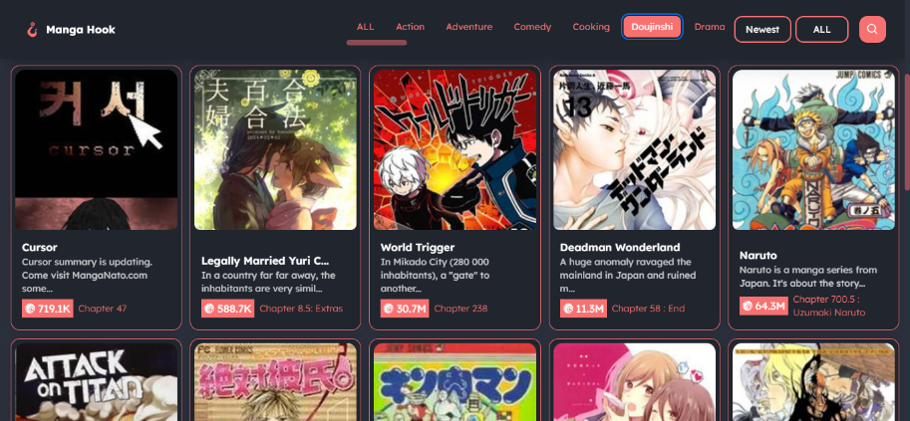

The navigation bar is located at the top of every page on Sailfin Manga, providing quick access to all major sections of the site:

* **Genres:** Click here to browse manga by category, such as Action, Romance, Fantasy, and more. This helps you easily find stories that match your interests.
* **Creators:** Visit this section to explore profiles of your favorite manga artists and writers. You can view their published works and learn more about their creative journeys.
* **My Library:** This is your personal space to access your saved manga titles, view your reading history, and manage your list of favorites.
  + **Favorites & Notifications:** To save your favorite manga titles, tap the ⭐ icon. As new chapters are published, you'll be notified

**READING MANGA**

|  |  |
| --- | --- |
| **Getting Started**  Click on any manga title to open its overview page.  **Reading Mode**   1. Select a chapter. 2. Choose your preferred reading mode. | Detail |